SOHAN M
1NT19IS155

Execrcise-3: Map Reduce (Programs)

Use the Hadoop framework to write a custom MapReduce program to perform word count
operation on a custom data set .

package PackageDemo;

import java.io.IOException;
import org.apache.hadoop.conf.Configuration;
import org.apache.hadoop.fs.Path;
import org.apache.hadoop.io.IntWritable;
import org.apache.hadoop.io.LongWritable;
import org.apache.hadoop.io.Text;
import org.apache.hadoop.mapreduce.Job;
import org.apache.hadoop.mapreduce.Mapper;
import org.apache.hadoop.mapreduce.Reducer;
import org.apache.hadoop.mapreduce.lib.input.FileInputFormat;
import org.apache.hadoop.mapreduce.lib.output.FileOutputFormat;
import org.apache.hadoop.util.GenericOptionsParser;
public class WordCount {
public static void main(String [] args) throws Exception
{
Configuration c=new Configuration();
String[] files=new GenericOptionsParser(c,args).getRemainingArgs();
Path input=new Path(files[0]);
Path output=new Path(files[1]);
Job j=new Job(c,"wordcount");
j.setJarByClass(WordCount.class);
j.setMapperClass(MapForWordCount.class);
j.setReducerClass(ReduceForWordCount.class);
j.setOutputKeyClass(Text.class);
j.setOutputValueClass(IntWritable.class);
FileInputFormat.addInputPath(j, input);
FileOutputFormat.setOutputPath(j, output);
System.exit(j.waitForCompletion(true)?0:1);
}
public static class MapForWordCount extends Mapper<LongWritable, Text, Text, IntWritable>{
public void map(LongWritable key, Text value, Context con) throws IOException, InterruptedException
{
String line = value.toString();
String[] words=line.split(",");
for(String word: words )
{
Text outputKey = new Text(word.toUpperCase().trim());
IntWritable outputValue = new IntWritable(1);
con.write(outputKey, outputValue);
}
}
}

public static class ReduceForWordCount extends Reducer<Text, IntWritable, Text, IntWritable>
{
public void reduce(Text word, Iterable<IntWritable> values, Context con) throws IOException, InterruptedException
{
int sum = 0;
for(IntWritable value : values)
{
sum += value.get();
}
con.write(word, new IntWritable(sum));
}

}

}

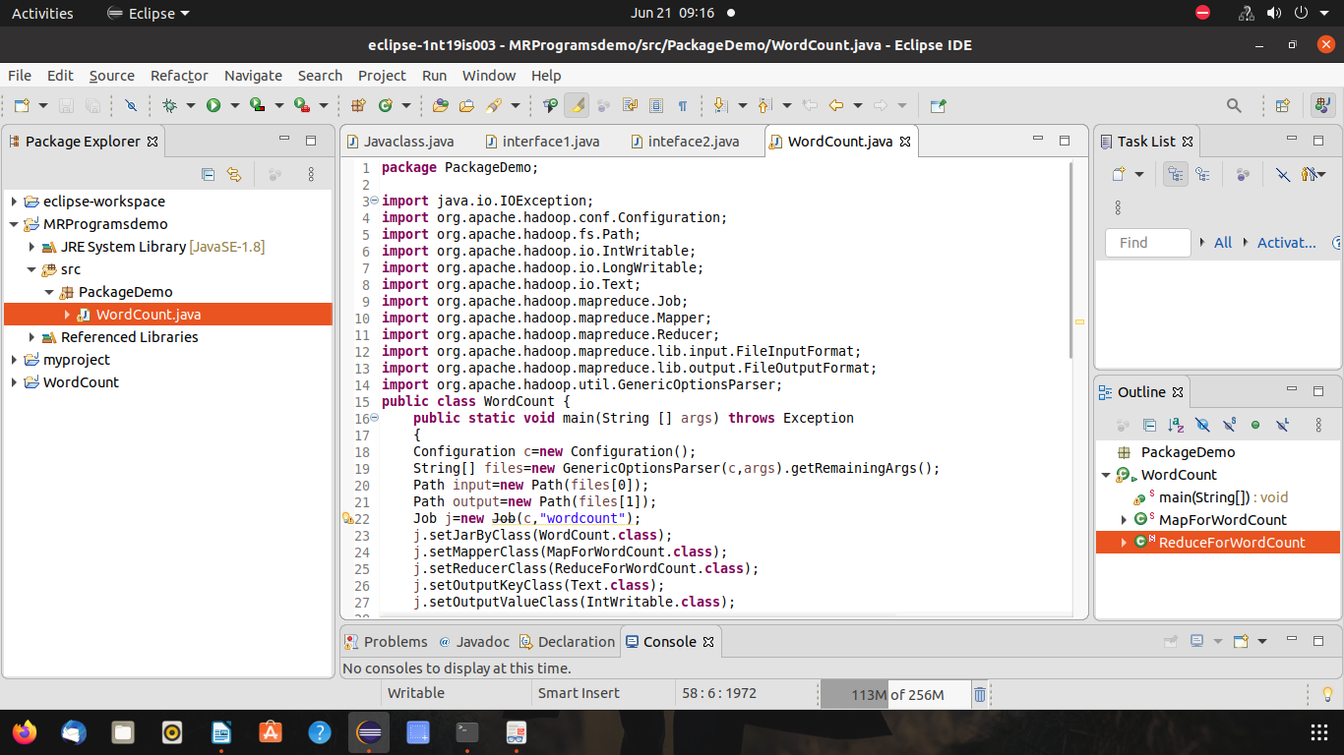

$ cd $HADOOP_HOME
~/hadoop-3.2.1$ cd sbin
~/hadoop-3.2.1/sbin$ jps

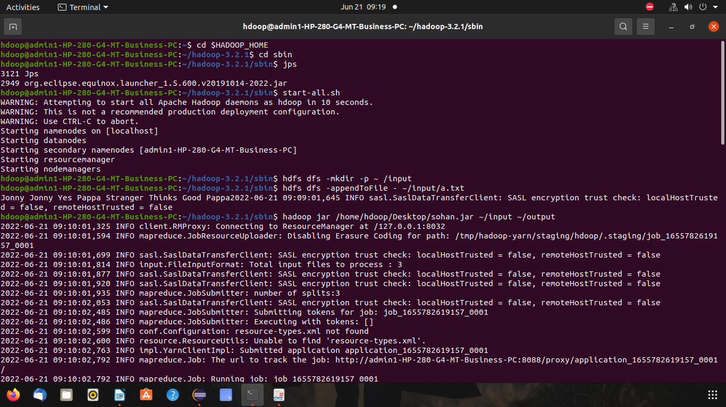

hdfs dfs -mkdir -p ~ /input
hdfs dfs -appendToFile - ~/input/a.txt

hadoop jar /home/hdoop/Desktop/sohan.jar ~/input ~/output

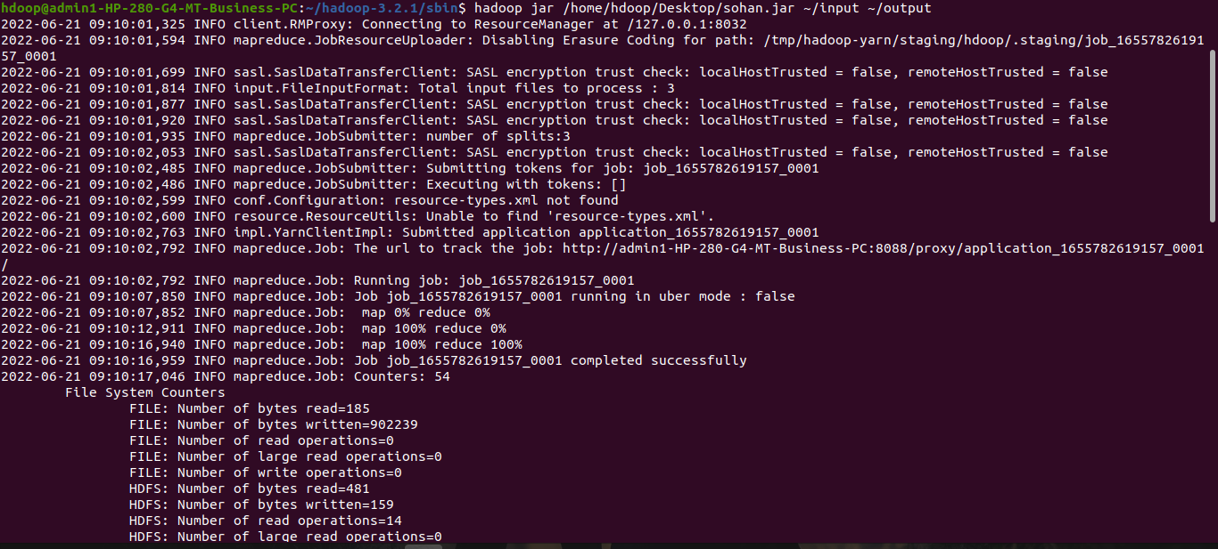

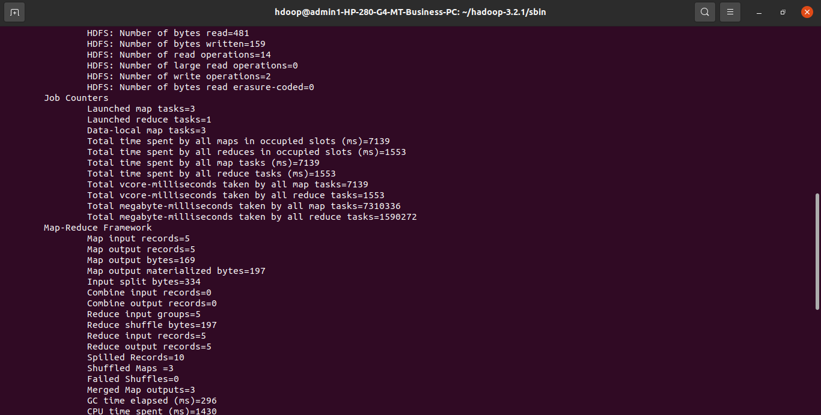

hdfs dfs -cat ~/output/part*

